Luke Evans

February 14, 2021

Lab 3 – TCP/IP Attacks

**Attacker IP = 10.0.2.15**

**Victim IP = 10.0.2.4**

**Server = 10.0.2.5**

* 1. *SYN Flooding Attack*

We check the size of the half open connection queue on our victim machine in the screenshot below:

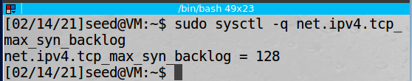

We can check the half open connections using the command nestat -at, shown in the screenshot below:

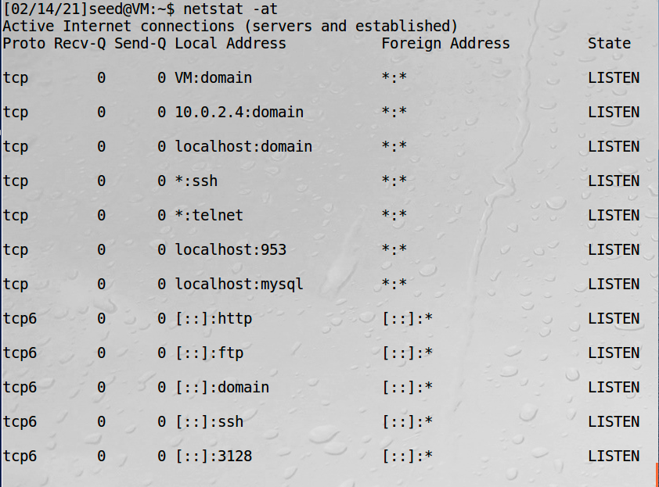

Next we will launch the attack from our attacking VM:

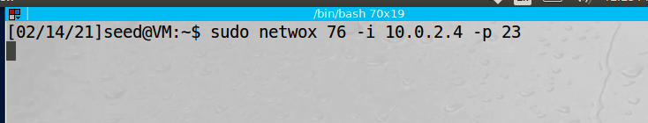

We can again run the netstat -at command to view the states of the connections while the attack is being launched:

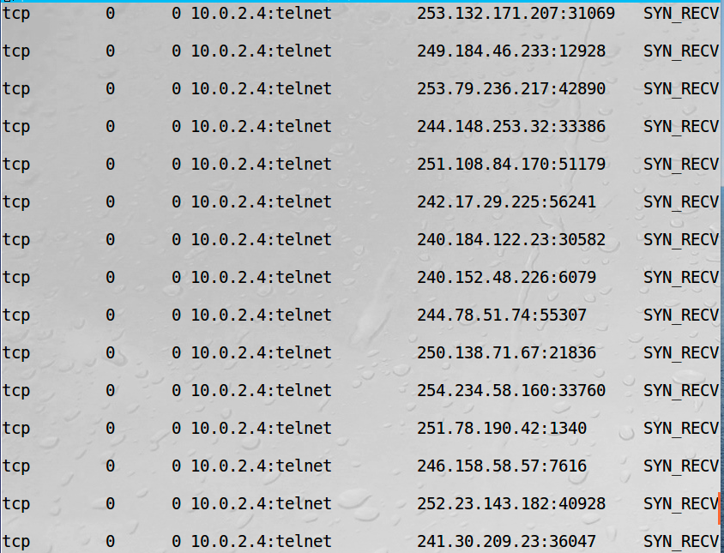

TCP syn cookies was enabled on our victim machine by default so for example purposes we first turn it off.

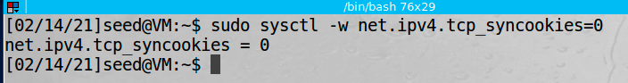

We then try to telnet to the machine from our server computer and are unable to connect because the half open connection queue is full and no other connection to port 23 can be made:

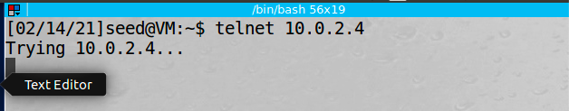

Next, we turn tcp syn cookies back on on our victim machine:

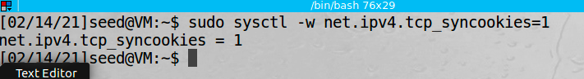

Then we try to telnet to the victim machine again from the server and we are able to make a connection:

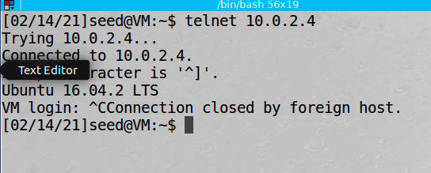

Observations: The screenshots above show an example of a SYN flood attack. We used the netwox tool to send many TCP SYN packets from spoofed source IP addresses which causes the victim machines half open connection queue to fill up. We target port 23 specifically so when we try to telnet to the victim machine from our server machine it does not work because the victim machine is no longer able to accept any other connections and we disabled the tcp syn cookie counter measure. When we reenable the tcp syn cookie counter measure, we can then make a telnet connection from our server VM to our victim VM even though our attacker is flooding the victim with TCP SYN packets.

Explanation: The TCP SYN flooding attack targets the bottle neck in the three way handshake. By filling the half open connection queue for a specific port, the victim machine will no longer be able to accept any other connections to that port number even though the machine has plenty of computing resources available. When the TCP SYN cookie counter measure is enabled our attack is unsuccessful because once the half open connection queue fills up, the victim machines OS will automatically start attaching tcp session cookies to the syn ack request and will no longer buffer the half open connections. Then when the victim machine receives an ACK packet it can check the SYN cookie to verify if it is a valid connection request before establishing a TCP session.

*2.1 TCP Reset Attacks on Telnet and SSH*

The server VM telnets to our victim VM:

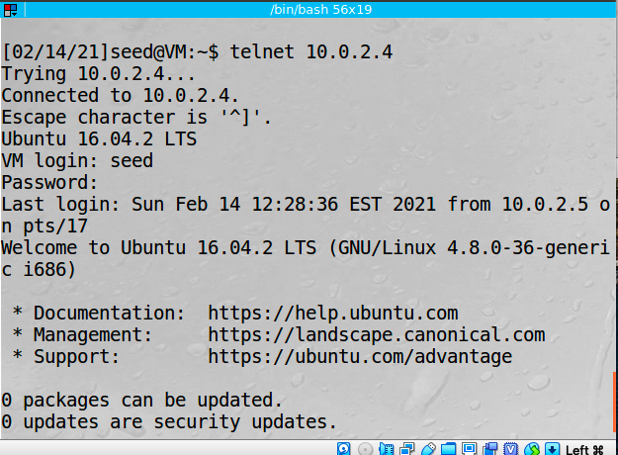

On our attacking machine we launch our attack using the netwox tool:

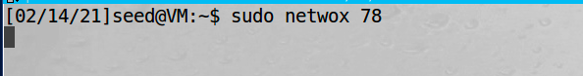

We then try to type something from our server that had previously opened a telnet connection to our victim machine and we can see that the connection as been closed:

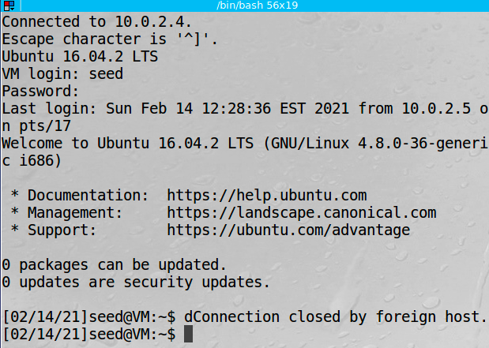

Next we will repeat the TCP RST attack on an open SSH connection. First we establish an SSH session between the server VM and the victim VM:

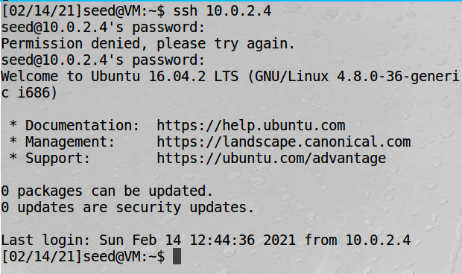

Instead of using netwox for our attack, this time we will use pythons scapy library. Our code is shown below:

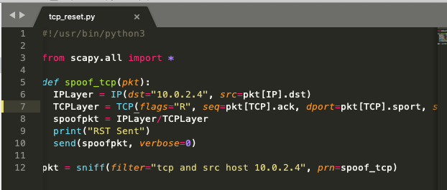

We then launch the attack from our attacking VM:

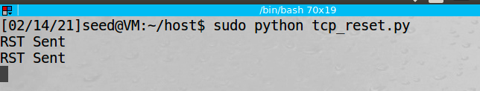

Next, we go back to our ssh terminal on the server machine and try to type a command:

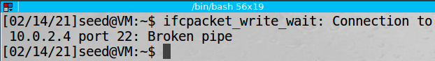

Observation: In this task, we launched a TCP RST attack from our attacking VM targeting a telnet session and ssh session between our server VM and victim VM. The first attack using the netwox utility resets all TCP connections on the LAN. We can see this by the fact that we did not specify any parameters. The netwox tool simply sniffs the TCP packets and forms and send out the RST packets. This is why our telnet connection was interrupted. In our second attack using scapy, we actually specify the IP that we want to target. In our case, it is IP address 10.0.2.4. The python sniffs packets from source 10.0.2.4 and then sends our RST packets when one is found which interrupts the tcp session. This is seen when the pipe is broken in our SSH connection between our server machine and the victim machine.

Explanation: The TCP reset attack’s objective is to break an existing connection between two victim hosts. The way it is done is by spoofing a TCP reset packet to cause one of the victim hosts to think the other victim host is closing the connection. This is done by sending a packet with the RST bit set to 1. When a properly formed RST packet is received, it causes the connection to be immediately broken. Under normal circumstances this is used in emergency situations or when errors are detected; however in the TCP reset attack the protocol rules are targeted as an attack surface.

The important areas of the reset packets are the TCP packet signature which includes source IP address, source port number, destination IP address, and destination port number. These four fields in the spoofed packet need to be the same as the fields used in the open connection otherwise the packet will be discarded. In addition, the sequence number used in the spoofed packet needs to be correct or the receiver will discard the packet. Theoretically, for the sequence number to be correct it just has to be in the receivers window in Linux it seems that it has to be the next sequence number or it will be discarded by the receiver.

*3.1 TCP RST Attacks on Video Streaming Applications*

We choose a random video on youtube.com and start streaming it:



We then use netwox to launch our attack from our attacking VM:

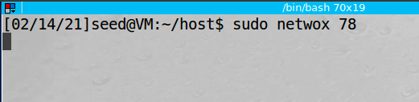

It takes some time to work as the data is buffered, but eventually the tcp connection is rst and the video stops playing:



Observation: We used the netwox tool to launch a TCP rst attack from our attacking VM to an other computer on our LAN. The command sends reset packets to all TCP connection on the LAN. We observe this by starting to stream a video, then running the attack, then waiting for the buffered data to run out and then we see the spinning wheel in the last screenshot.

Explanation: Video streaming services use TCP protocol when streaming data from their servers to the client machine. All TCP sessions are vulnerable to TCP reset attacks if the attacker knows the tcp signature of source port, destination port, source IP, destination IP in addition to the next sequence number. Since we are running an attack from the same local network, we can easily sniff this packet information as it is unencrypted and send the spoofed RST packet to close open TCP connections. That is what the netwox tool is doing internally.

*4.1 TCP Session Hijacking*

**Attacker IP = 10.0.2.15**

**Victim IP = 10.0.2.4**

**Server = 10.0.2.5**

*4.1.a Using netwox*

First we telent from our client to our server:

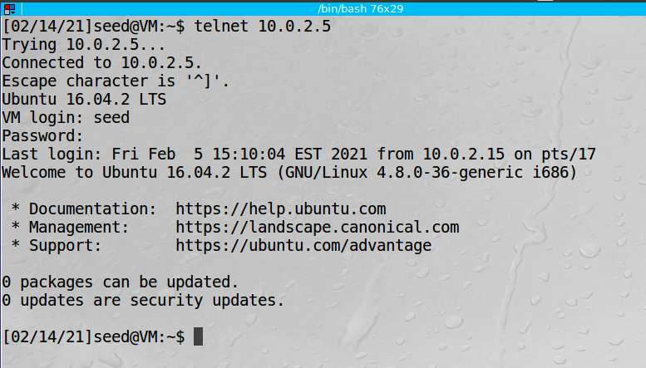

We sniff this data from wireshark on our attacking machine so that we can get the necessary packet info to perform our tcp session hijacking:

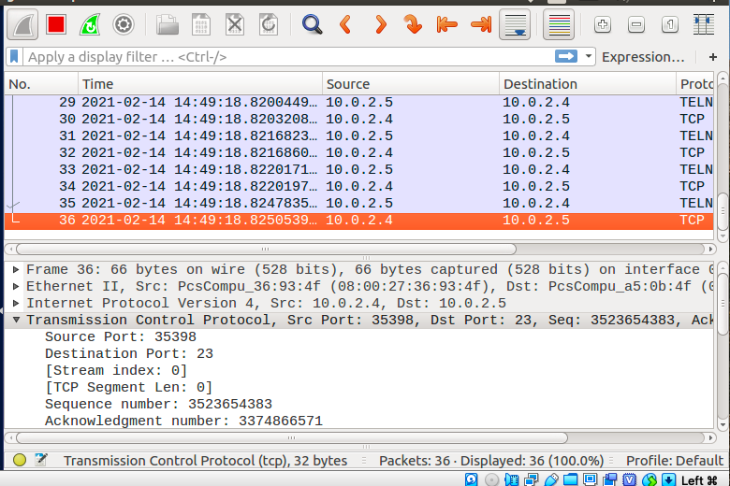

We start a tcp server on our attacking machine:

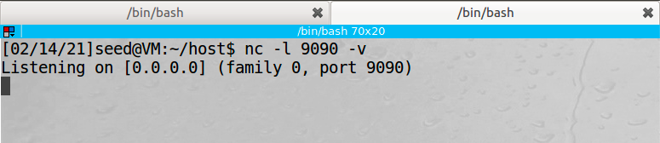

We can then use this information to form our tcp session hijacking attack on the attacking machine:

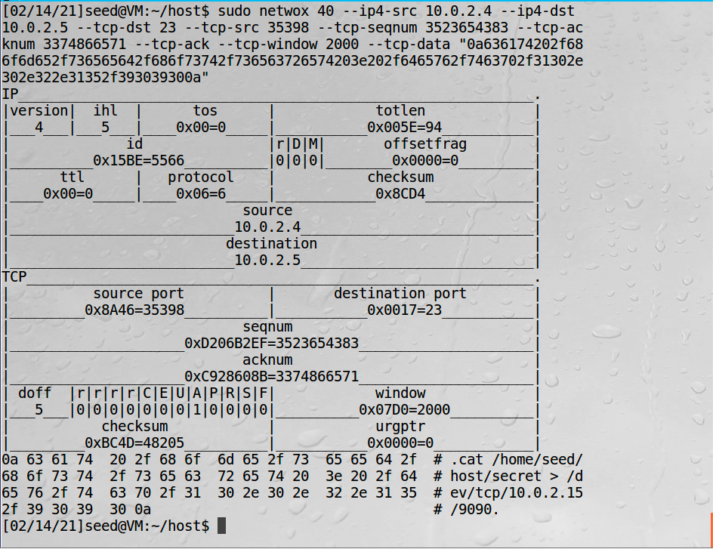

From our netcat server we can see the data:

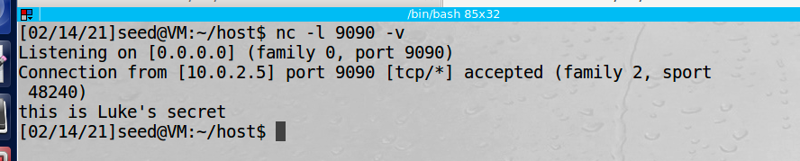

We can see the spoofed telnet packet in wireshark:

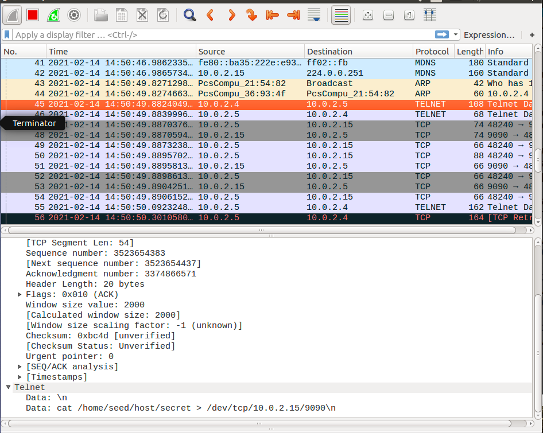

Observation: This attack used the netwox tool to hijack a tcp connection between our client on IP 10.0.2.4 and server on IP 10.0.2.5. In order to perform this attack we needed to sniff the packets to figure out the source and destination IP address, the source and destination port numbers, sequence number, and acknowledgement number. Next we set a tcp server on the attacker machine using netcat tool. Then the attack command was sent in our spoofed tcp pack with the output redirected to a tcp connection to our attacking IP of 10.0.2.15. Once the attack was performed the clients terminal froze because of a packet deadlock due to us causing a change in the expected sequence number.

Explanation: Using the netwox tool we are able to able to inject a tcp packet into a tcp session that is using telnet. We were able to read data from a secret file that we should not have been able to access. This was easier than in real life since we are on a LAN we could sniff the source port and random sequence and acknowledgement number. If we were not on the same LAN we would have to guess these numbers which would make our attack much more difficult.

*4.1.b Using Scapy*

First we sniff the packets to find out the sequence number, source port number and acknowledgement number:

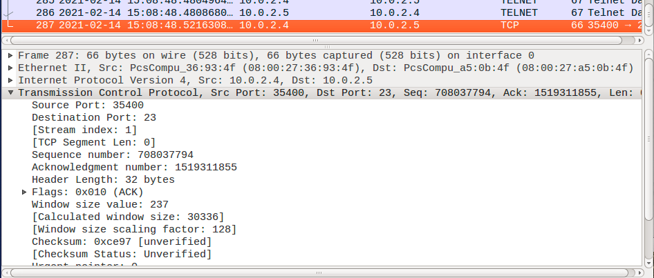

Then we write our python code leveraging the scapy library:

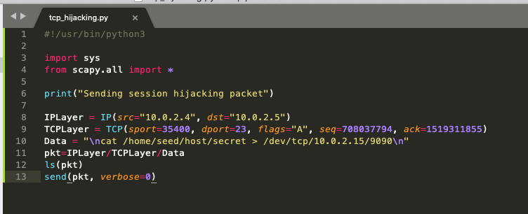

We run the code from our attacking machine:

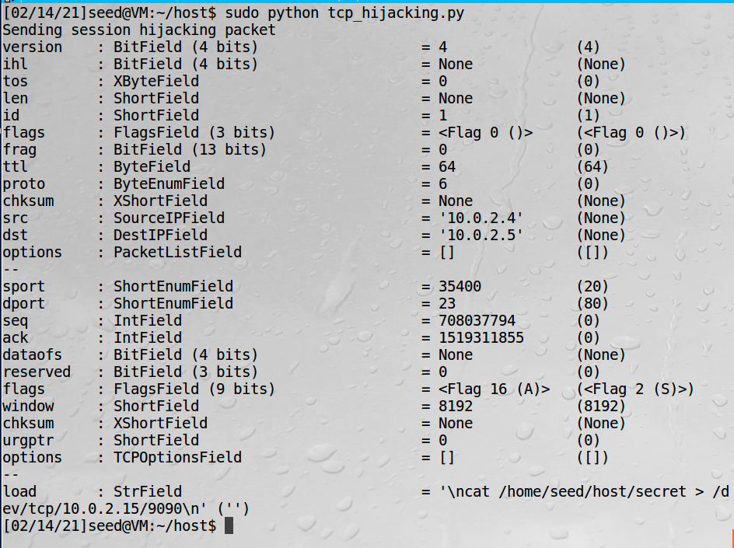

Then we can view the secret file that is printed in our tcp server running on the attacking machine:

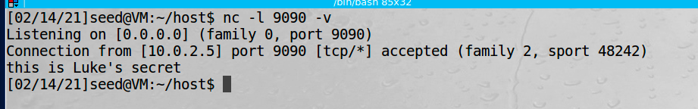

Observation: Just like in our previous attack, we can perfrom a TCP session hijacking on the telnet session between 10.0.2.4 and 10.0.2.5 but this time we used scapy. The first thing we needed to do is sniff the ip addresses, the port numbers, the sequence number, and the acknowledgement number. We then run a tcp server using netcat listening to port 9090 on our attackers machine. We wrote our attacking program in python and run it from our attacking machine. We are able to read the secret file and it is outputted to our tcp server due to the command that we sent and redirection of the output to tcp connection and the attacker IP 10.0.2.15.

Explanation: In this task we used Scapy to send a spoofed tcp packet and hijack the telnet tcp session between the client and server. We were able to print out file data from the server that the attacker should not have been able to access by passing a malicious command and redirecting the output to a tcp connection pointed at the attackers IP address.

*5.1 Creating Reverse Shell using TCP Session Hijacking*

First we need to sniff the packet so that we can perform the tcp session hijacking:

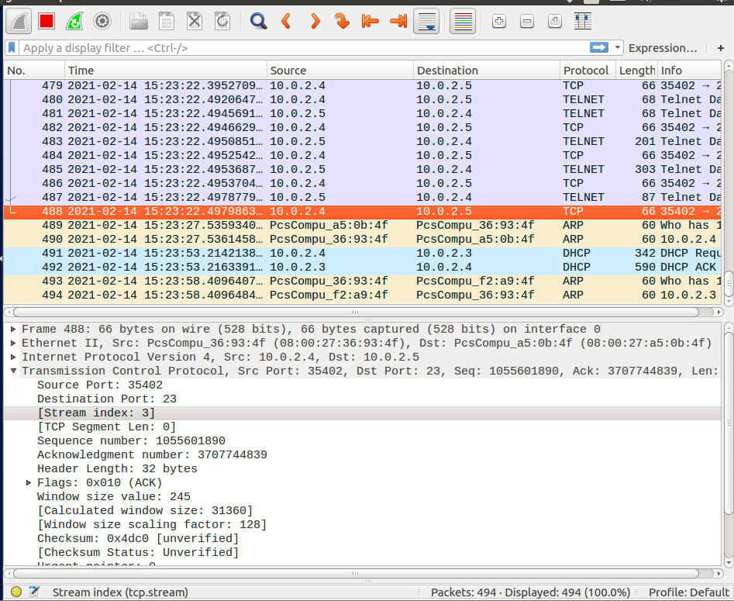

We then modify our scapy code to have the new command, and new tcp session info:

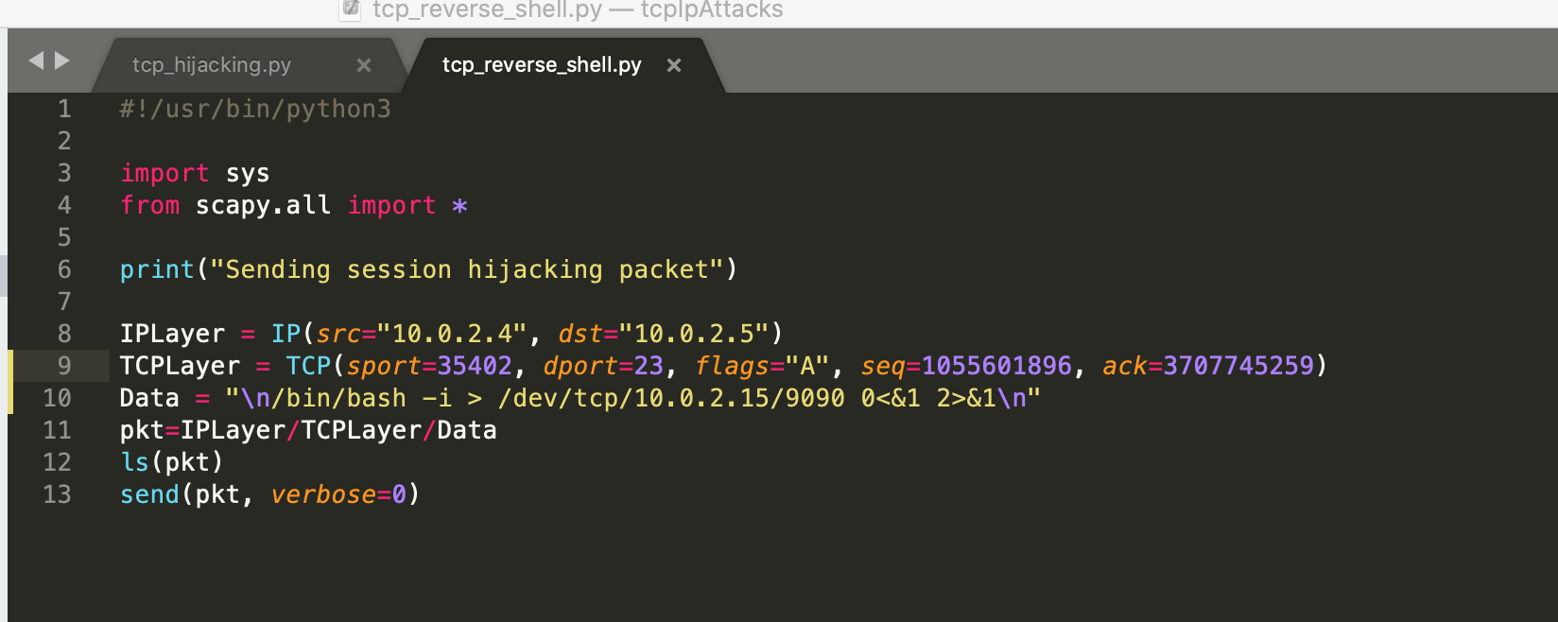

Next, we run our code on the attacking machine:

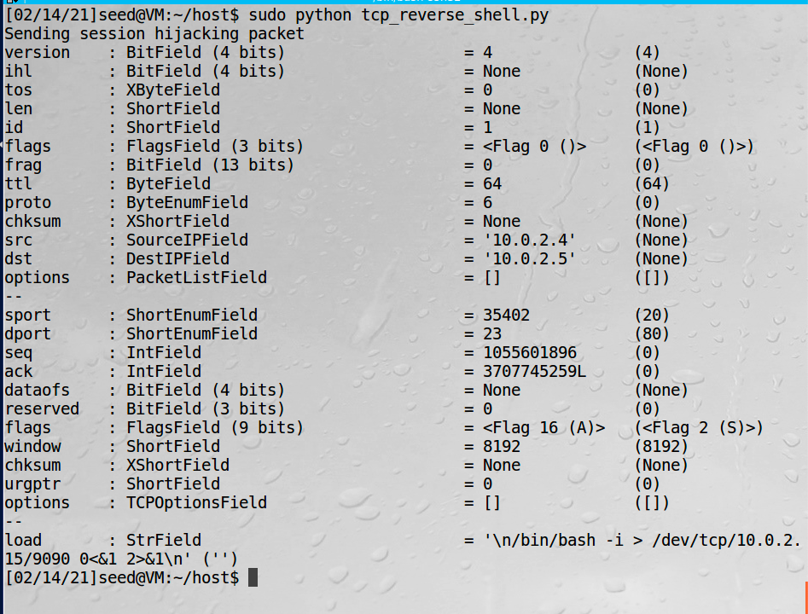

When we go to our netcat server we can see a connection has been established on the attacker machine and when we run the ifconfig command we see the IP of the server 10.0.2.5:

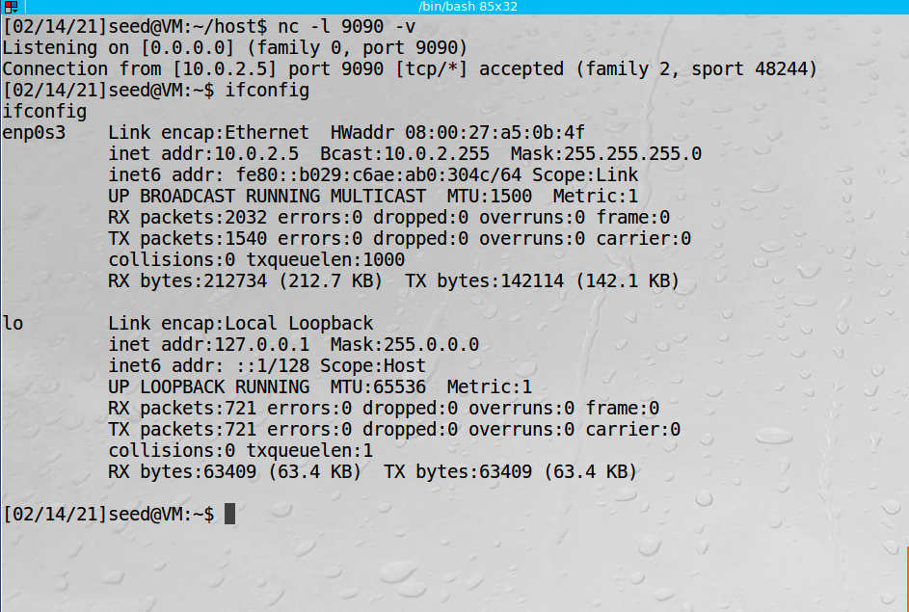

Observation: This attack was essentially the same as the previous section only the command we used created a back door for out attacker onto the server. The first thing we needed to do was sniff the necessary data from the tcp session. This included the source and destination IP addresses, the source and destination port numbers, the sequence number, and the acknowledgement number. Once we had that data we used scapy to create our spoofed packet. Before launching our attack we run a tcp server listening on port 9090 using netcat. Then we run our python code to spoof the packet and we now have a connection to the server on our attacking machine via a reverse shell. To achieve this we had to redirect the standard input, output, and error to our attacking machines tcp connection which gives us full control. The attack was successful and you can see that the ip printed from ifconfig command on the attackers terminal shows the server IP.

Explanation: In this task we used Scapy to send a spoofed tcp packet and hijack the telnet tcp session between the client and server. We created a reverse shell which created a backdoor for the attacker onto the server. This attack is more similar to a real world attack because instead of just running a single command, we can now do whatever we want on the server through the reverse shell.